MENDIP VALE MEDICAL GROUP PATIENT PARTICIPATION GROUP MEETING
Wednesday 11th February 2026, 1:30pm

PPG Attendees | Mary Adams  Sandra Dunkley  Janet Beckett  Linda Brimecome  Heather Pitch  Geoff Matthews  John Gowar  Ruth Crick  Georgie Bigg  Maureen Hutchinson  Clive Harper  Alan Hunt  Richard Hamilton-James  Geoff Richardson | Chair  PPG Member (Riverbank/St Georges)  PPG Member (Riverbank/St Georges)  PPG Member (Riverbank/St Georges)  PPG Vice Chair and Virtual Chair (PPL Member)  PPG Member (PPL)  PPG Member (PPL)  PPG Member (PPL)  PPG Member (PPL)  PPG Member (PPL)  PPG Member (Yatton and Congresbury)  PPG Member (Yatton and Congresbury)  PPG Member (Sunnyside)  PPG Member (Sunnyside)
MVMG Attendees | Dr Joanne King  David Clark  Leigh Vowles  Lois Reed | GP Partner  Managing Partner  North Somerset Divisional Director  Comms and Engagement Manager
Apologies | David Gent  Sheila Williams  Diane Haynes  Sally Burrell | PPG Member (PPL)  PPG Member (Riverbank/St Georges)  PPG Member (Yatton and Congresbury)  PPG Member (Sunnyside)

Action Points Summary

Item | Action Taken By | Action Description | Completion Note
 | LR/MA | eConsult to remain on future agendas
 | AD | Telephone monthly updates to be circulated
 | DC | Updates on Congresbury
 | LR | Virtual meeting on next agenda
 | SP | eConsult Feedback
 | LR/ DG | Review text sent to patients
 | LR/MA | Add the processing of Death Certificates to agenda in April
 | LR | Volunteer Driver Article in Patient Newsletter
 | LR | Item on MVMG KPIs | Complete
8 | LR | Dashboard amendments

Minutes:

Item | Description | Action
1 | Apologies  Shelia Williams, Diane Haynes, David Gent, Sally Burell (New Member)  The group welcomed Geoff Richardson and Richard Hamilton – James.
3 | Virtual PPG Updates – 21st January 2026  Heather Pitch gave an overview on the latest virtual PPG meeting held on the 26th of January 2026. Heather noted that there were 9 attendees with a couple new members which was great to see.  - eConsult access hours meet Government guidelines. It is never switched off during core hours. To accommodate restricted opportunities to complete an eConsult, suggestion to open it at 07:00 hrs.  - Surgery opening hours: For the last 12-13 years there has been an early morning surgery starting at 06:00 hrs on a Tuesday. Take up for the Saturday morning surgery has been very good but DNAs are highest then (7-8%). There is also a rota for Saturday afternoons shared with other practices across Woodspring.  - Static nature of current MVMG website: No mention of early morning booking slots and adding information to the website explaining the difference between urgent and routine appointments, along with a description of the duty doctor’s role  - Bristol and South Gloucestershire Virtual PPG Merge: It was agreed that Bristol & South Glos PPG members will be invited to join the virtual meetings.  Although the feedback was entirely favourable, further discussion took place during the in-person meeting regarding how this would work operationally, particularly in relation to the different MVMG representatives and the agenda. Georgie Bigg noted that gaining different perspectives on the same issues would be valuable but recommended that this approach should be trialled to assess its effectiveness. Mary Adams and Heather Pitch agreed to take this away for further consideration and explore how it could work in practice operationally.  - Virtual Meeting Agenda: Items for discussion should be submitted in advance, allowing the practice time to prepare responses. This will enable a structured agenda to be shared ahead of the meeting.
4 | Minutes of Previous Meeting 10th December Accuracy  Minutes of previous meeting were approved as an accurate reflection of the discussion which took place. Nothing to note from previous meeting.
5 | Congresbury Surgery  Lois Reed explained that on 10 November, the HOSC panel held an initial virtual meeting with members of the Integrated Care Board (ICB), alongside herself and David. Following this meeting, a number of questions were raised. A further meeting with ICB representatives was held in January to discuss the next steps in relation to these queries, including gaps within the Impact Assessment, sharing data from the Congresbury patient survey with the aim to ensuring that any missing information is fully addressed.  The public HOSC meeting is scheduled for the 12th of March. Depending on the outcome, the matter will then proceed to PCOG on 14 April for a final decision. Relevant dates are now in place, and it is hoped that an outcome will be reached in April. Mary Adams has confirmed that she is happy to represent patients.  Geoff Matthews raised a question regarding ownership of the building. It was confirmed that MVMG owns the property, with ongoing property and maintenance costs of approximately £38,000 per year.
6. | PPG Satisfaction Survey  Ruth Crick provided an update on the patient satisfaction survey as per the analysis plan of 1) Consensus building 2) identifying key themes for change 3) what can we do to make the change? The group held their first off-site workshop, where they had 9 attendees, to look at the results in depth. Within this session, the group identified key themes and raised several questions to support the next workshop session. The agreement within the group was that there were repeated reports of delay, confusion and loss of continuity which should be taken seriously for patient safety. The next steps are for the group to have their second workshop to bring the key themes back to the group and the next PPG meeting.  Mary Adams suggested that due to the phenomenal response and the methodological work the group are doing to support the practice that these finding should be presented to Geoff Farrer, Chair of the ICB, as evidence of best practice.
7 | MVMG KPIs  Following the last in-person meeting, a request was made to better understand the practice’s Key Performance Indicators (KPIs), including what is currently monitored, how performance is reviewed, and how any areas of concern are followed up. David Clark presented both the daily and weekly KPI dashboards, which provide management with oversight of operational performance across the practice. He explained that the daily spreadsheet is shared with the team every morning, with data available from 6:00am to support planning and action for the day ahead. This dashboard includes the number of eConsults, hospital documents, emails, and prescriptions, alongside the age of outstanding work, the number of hours required to clear the workload, and the productivity needed to remain on track. The tracker is colour coded to provide a clear visual indication of performance and is used to ensure workflow traffic is monitored and managed in a timely way, while also helping identify the reasons for any delays or underperformance. It also allows comparison of performance between the Bristol and North Somerset sites.  David went on to explain that the weekly KPI tracker serves as an end-of-week review tool, providing a broader picture of performance trends. The weekly measures include completion rates for typing, outstanding tasks, document workflow, and laboratory results. The turnaround standards are:  - urgent typing and tasks within 24 hours  - routine typing and tasks within 7 days  - document workflow within 72 working hours  - laboratory results maintained below 600 with items for North Somerset for Bristol having thresholds set that reflect patient list size.  Dr King noted that the practice typically receives around 1,200 lab results each day, with KPIs completed within five working days unless a result is clinically urgent.  In response to a question from John Gowar regarding how these KPIs are reviewed, David confirmed that an operational meeting takes place every Friday morning with senior management. This meeting provides an opportunity to review performance, identify pressure points, and hold supportive conversations with specific team members where required. In addition, partners hold a brief meeting each Friday to follow up any actions that need to be completed, ensuring continued oversight and accountability. Finally, David also presented the clinical KPI dashboard, which tracks key clinical safety and quality indicators, including flu vaccinations, child immunisations, health checks, and serious mental health reviews, helping the practice maintain oversight of both operational efficiency and clinical quality standards.
8 | Action Plan update  The group reviewed current demand volume and access performance, noting that the number of phone calls remained strong across December and January. It was observed that the usual seasonal pattern was evident, with demand dropping during the Christmas period in December before increasing sharply again in the New Year. Despite this fluctuation, performance remained aligned with the practice’s three-minute KPI for patient queue waiting time, which continues to be closely monitored.  A similar demand trend was noted for eConsult activity, with volumes mirroring the telephone pattern across the same period. It was highlighted that there had been an error in the originally reported January data, and the correct figure should read 6,874 eConsults for January rather than 1,074, as the lower number reflected one week of activity rather than the full month.  The team also reviewed responsiveness against the three-working-day contact standard, confirming that activity is tracked daily. During the reporting period, seven cases fell outside the three-working-day timeframe for patient contact. It was noted that these delays were attributable to patients choosing to wait for a specific clinician, rather than process delays within the operational workflow.  Patient experience data from eConsult was also shared, showing positive performance, with 94% of patients reporting that they received a response within three working days.  During discussion, Geoff Matthews asked whether the same telephone number continued to be used across the service. Leigh Vowels confirmed that this remains the case. Geoff also shared that he has had less feedback from patients regarding not being able to get though on the phones.  The group requested that the DNA and appointment data be presented in a table format consistent with the rest of the dashboard, to enable clearer comparison with previous months and support trend analyses over time. | LR
9 | MVMG Screening Task and Finish Group – Lung Cancer Screening Presentation  Lois Reed presented an overview of the national cancer screening programmes, covering breast, cervical, bowel, and the newly introduced lung cancer screening programme, all of which are designed to support the earlier diagnosis of cancer and improve patient outcomes.  The lung cancer screening programme focuses on:  - People aged between the ages of 55 and 74 who are current or former smokers – ‘closed invite’  - People aged between the ages of 55 and 74 who have no smoking status coded on their practice records – ‘open invite’  - National programme sends three invites for patients to have an initial telephone assessment  It was noted that screening uptake rates have remained stubbornly static, despite a range of local and national campaigns and targeted interventions. Uptake continues to be significantly lower in certain patient groups, particularly:  - Areas of deprivation  - Global majority groups - understanding and addressing the reasons which may affect screening attendance e.g. culture, language  - Other inclusion health groups e.g. refugees, travelling communities  Lois advised that the attached presentation provides further detail on the screening programme and current challenges. The primary purpose of the discussion was to gather Patient Participation Group (PPG) ideas on how the practice can improve patient engagement and increase uptake across all cancer screening programmes.  Initiatives already in place include:  - During discussion, PPG members suggested several additional engagement ideas, including:  - Increasing awareness within surgeries through more visible TV messaging and posters  - Including regular screening promotion in the practice newsletter  During discussion, PPG members suggested several additional engagement ideas, including:  - Increasing awareness within surgeries through more visible TV messaging and posters  - Including regular screening promotion in the practice newsletter  - Roma and Traveller group at St Andrews Church ran by North Somerset Council  - Targeted outreach in community settings frequently used by the relevant demographic, such as local pubs and other informal social venues, to raise awareness and encourage greater screening uptake.  - Suggested having dedicated clinic event days like the covid and flu vaccination  - Education events at Village halls with the support of PPG  - Podcast  - Men’s health groups to have posters in the men’s bathroom  Members were encouraged to continue sharing ideas and feedback directly with Lois Reed via email at bnssg.mvmg.comms@nhs.net
10 | Any Other Business:  - National Association of Patient Participation Closure  Geoff Matthews reported that NAPP is due to close at the end of February. No official reason has been provided, although it is suspected to be related to funding. This is disappointing for the PPG and wider patient representation.  - Death certificate  David Gent requested that death certification be included as an agenda item for the next meeting.  - Aircon in the group room  John Gowar asked whether a proposal could be developed for installing air conditioning in the group room and whether potential funding options could be explored for it. David Clark advised that the estimated cost would be £86,000. He noted that air conditioning is already available in the waiting areas and, given that the group room is currently used only twice a month, questioned whether this would represent good value for money.  - Afternoon Appointments  Janet Beckett queried the limited availability of afternoon appointments. Dr King explained that routine eConsult appointments are not evenly distributed between morning and afternoon sessions. Afternoon capacity is intentionally kept as flexible as possible to accommodate urgent, same-day cases. Where possible, routine afternoon appointments are released after 4pm to enable patients who have submitted an eConsult to be seen more quickly. While this approach is preferred, patient safety and urgent demand must take priority.  - Policy for neurodiversity  Janet Beckett raised concerns that patients with neurodiverse conditions may lack the support or confidence to attend appointments, particularly where communication is challenging. As a result, some may attend hospital instead or not seek care at all. She asked whether a specific policy is in place. Dr King advised that it is important for the practice to be aware of any neurodiversity and individual communication preferences, as these can be recorded in the patient’s medical record. This enables both clinicians and administrative staff to make appropriate adjustments and support access to care. However, the practice is unable to provide entirely separate access pathways.  - Out of hours PPG  Geoff Richardson noted that the Out of Hours PPG has offered to deliver a presentation to the MVMG PPG to provide updates. The group agreed this would be beneficial.  - Numed focus group Research for General Practice  Mary Adams reported that she and Tim Evans participated in a Numed focus group, which explored patient perspectives on general practice. Feedback indicated it was a valuable and engaging discussion. This initiative involves GP practices opting in to share patient data with a research body, enabling patients to be invited to participate in research programmes. Mary commented positively on the level of care and the robust processes involved. | LR
8. | Date of next PPG and Virtual Meetings  - Date of next Virtual Meeting: 18th March 2026  - Date of next In-Person Meeting: 22nd April 2026  2026 Meeting Dates:
  Virtual Meetings | In person meetings
  - 20th May  - 15th July  - 16th September  - 18th November | - 22nd April  - 17th June  - 19th August  - 21st October  - 16th December

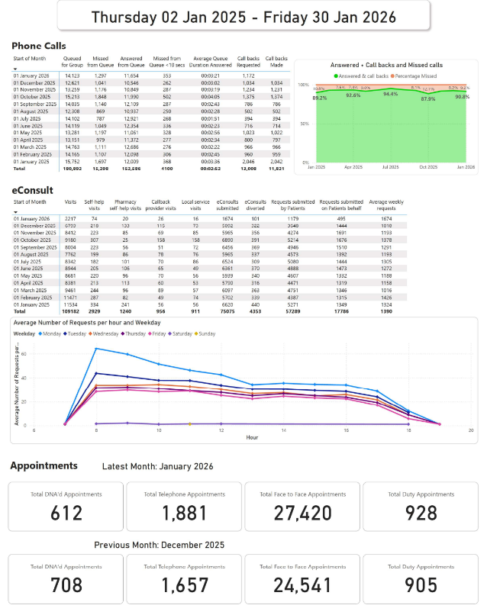
Appendix 1: Dashboard

